New Mexico Historic Preservation Division

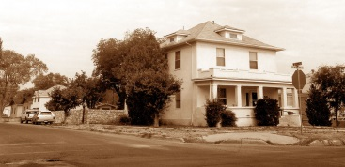State and National Register Preliminary Questionnaire
This questionnaire is designed to help you and HPD determine whether a property is likely to be eligible for listing in the State Register of Cultural Properties (State Register) or the National Register of Historic Places (National Register).

1. Location of Property
Address:
City or locale:
County:

2. Historic Name of Property

3. Current Owner Name & Address
Name:
Address:
City:
State:
Telephone Number:

4. Use of Property
Historic:
Current:

5. Date of Construction, if known

6. Architect or Builder, if known

7. Property Description (describe major features of the property, including construction materials, number of stories, roof, windows, doors and architectural elements; describe any other features, including mature landscaping, signage, outbuildings, etc., if appropriate):

8. Changes to the Property (list dates of major additions, alterations, or demolitions and describe what they were):

9. Historical Background (discuss events or persons associated with this property):

10. Sources of Information (identify sources of information):

11. Photographs (please submit recent photographs that show all sides of the property and its immediate setting and associated buildings, structures or objects that might be included in a nomination. If available, send copies of older photographs of the property. Photographs can be added at the end of this document or as JPGs to an email submission.)

12. Location Map (that shows the relation of the building to roads or other landmarks).

13. Why is State Register National Register Listing Being Sought?

14. Person Completing Questionnaire:

Name:
Address:
City:
State:
Telephone Number:
E-mail:

Please send completed questionnaire to:
Steven Moffson
State and National Register Coordinator
steven.moffson@dca.nm.gov
New Mexico Historic Preservation Division
407 Galisteo Street, Suite 236
Santa Fe, NM 87501

If you have questions about this questionnaire or the State and National Register programs, please call:
505-476-0444.

Add photographs here or add to email.

