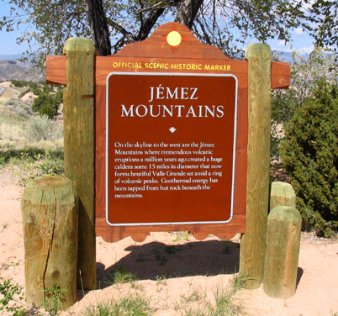 |  |  |  | New Mexico Official Scenic Historic Marker Program  Application Form
Name of Marker:
County:
Review:
 |  | New Marker |  |  |  |  |  |  | Revised Text
 |  | Original Text/Replacement Marker |  |  |  |  |  |  | Move of Existing Marker
Text:
 |  | One-sided |  |  |  | Two-sided
Suggested Installation Site:
Proposed Text: |  |  |  |  |  |  |  |  |  |  | Word Count:
 | Type marker text here (50-80 word limit per side)

Applicant Name:
Organization (if applicable):
Address:
Phone Number: |  |  | Email:
Researcher/Author:
References/Source(s):
For HPD Staff:
CPRC Meeting Date: |  |  |  |  |  |  | Text Approved by CPRC Date:
CPRC/Staff Comments:
 | Type comments here
NMDOT District: |  |  |  |  |  | NMDOT Highway:
For Referral to:
Previous Title & Text:
 | Type previous text here

Send this form and any additional supporting documentation via email to matt.saionz@dca.nm.gov.

